The Environment and its Management
1. Vision
1.1 The following vision has been set within the Neighbourhood Plan framework:
- Ensure our diverse natural environments including woodland, farmland under high stewardship, streams flowing through the parish and parkland will be monitored, preserved, and protected to ensure key species thrive and bio-diversity increases.
- Sufficient allotment plots will be available for parishioners who want one and a community orchard shared by all.
2. Environment Objective
2.1 The following environment specific objectives have been set:
E01 To assess the current condition of our woodlands in conjunction with the relevant agencies to determine maintenance needs and enhancement possibilities.
E02 To increase the acreage of woodland that is accessible to parishioners and visitors whilst protecting wildlife.
E03 To assess and monitor wildlife areas in liaison with the relevant organisations and agencies. These will include riverbanks, set-aside and parkland.
E04 To publicise and promote the principles of higher level stewardship (renamed and hereinafter referred to as the Countryside Stewardship Scheme CSC) and the benefits this brings to all who grow crops and maintain land in the parish.
3. Community Objective
3.1 The following environment specific community objectives have also been set:
CF02 To identify suitable land for the Northill Parish Council to lease to meet its statutory obligations to provide allotments for parishioners (as endorsed in GIP)
CF03 To locate and secure a site suitable for development as a community orchard possibly in conjunction with allotments.
4. Report Summary
4.1 With regard to the woodland typology it is evident that all the important woodlands in the parish have management plans in place via the various agencies and owners that manage the sites. Objectives are clear and they broadly fit with the environmental vision and objectives set by the Neighbourhood Plan. The only exception relates to improved community access and the NP should seek to encourage this at sites such as Home Wood and College Wood. The creation of new woodland on open land to the east of the parish might significantly alter the open nature of the eastern area to the detriment of migrating birds. If the NP was minded to include such a proposal within the action plan further advice from specialists would need to be sought to ensure that such action is not detrimental to other environmental needs.
4.2 Cropped land provides a wonderful opportunity to establish improved field margins and new hedgerows more especially if the regularisation of irregular shaped fields in line with the HLS scheme is adopted by more land owners.
4.3 The adoption of Local Green Spaces as identified within the GIP is to be encouraged and more importantly developed as policy within the NP.
4.4 “Secret of the Sands” - The Greensand Ridge Project
Northill Parish lies on the Greensand Ridge. The “Secret of The Sands” Project is a partnership project funded by The Heritage Lottery Fund and administered by BRCC to raise awareness amongst local people and visitors of the Ridge’s unique heritage, and involve them in creating a sustainable future.
The project has several aims which will be pertinent to the emerging Environment Policy of the Neighbourhood Plan; namely
- To restore and strengthen landscape character in the area, focusing on key habitats and built environment features intrinsic to the landscape;
- To reconnect local communities with their landscape;
The two areas of project activity which most closely connect with the environmental objectives of our plan are
- the conservation and promotion of ancient and broadleaved woodland and
- the restoration, conservation and promotion of historic parkland and wood pasture.
Our historical parkland at Ickwell Park has been identified by the project as a possible area for conservation and promotion. We suggest the NLC and Neighbourhood Planning Group consults with Claire Poulton, the Secrets of the Sands Landscape Partnership Programme Manager on intentions, funding and partnership opportunities before the NP Environment Policy is finalised.
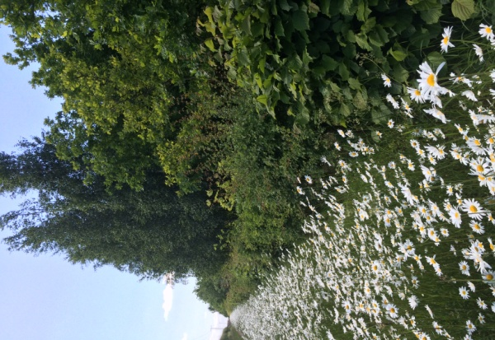
4.5 The Countryside Stewardship Scheme operated so successfully across Caldecote Farm holdings should be held up as a shinning exemplar of what can be achieved by local landowners. The NP should seek to encourage local landowners to participate in similar schemes and there needs to be more information made available to local residents about the importance of such schemes and the positive contribution that they can make to the environment. It is however possible that some landowners are involved in similar schemes and it is suggested that this should be further investigated within the NP as a specific action.
CSS field margin on Caldecote House farmland
4.6 The NP should seek to establish a greater understanding of the importance of the Warren Villas wetland habitat and work closely with the landowner to improve managed access to this valuable habitat.
4.7 Grazing land and permanent grassland provides good open land in contrast to the wooded and wetland areas of the parish. This character should be retained and calls for additional woodland and built development in these areas will need careful consideration if the parish is to avoid spoiling this aspect of the parish environment.
4.8 Open Spaces should be managed and developed in future in line with longer term management plans that are sympathetic to the needs of each area and the diversification of habitats. However, it is important to recognise the contribution that these spaces and their associated boundaries, water courses and feature make to the daily life of residents. They are often the most accessible green spaces within our parish and as such the communities need for informal recreation, dog walking and the like must be well balanced with natures needs
4.9 The development of gateway features that help express the identity of the parish and its villages and create memorable moments for those passing through should be supported by the NP. However, it is important that they are sympathetic to the landscape and not overly manicured or elaborate. Memorable public art could be incorporated along side traditional features such as hedge laying.
4.10 The opportunity to develop a good quality well managed allotment space and community orchard is only hampered by the lack of available land at the present time. It is hoped that the completion of the housing land analysis and the inclusion of allocated housing land within the NP will result in landowners coming forward to discuss other uses such as allotments for their land. There is a strong commitment from the NPAA and the Parish Council to develop a site was once this hurdle is overcome.
5. Introduction
5.1 As part of the process of developing the Northill Parish Neighbourhood Plan the plan team have paid a great deal of attention to listening to the thoughts, ideas, aspirations and frustrations of local parishioners. These have been collected and collated by a variety of means including, questionnaires, workshops and feed back sessions. As a result, local people have shared a great deal for the Environment Working Group to consider, discuss and analyse and these are collected together in Appendix 1 - Responses from Public Consultation Workshops June – September 2015.
5.2 The Working Group have examined each of these issues in turn and they are dealt with more fully throughout section 8 of this report depending on the typology that they fall under.
5.3 In addition the Working Group has examined a number of documents, maps, plans and initiatives obtained from a wide ranges of sources to gain an overall understanding of the state and condition of the parish environment and to identify best practice and areas for improvement.
5.4 It should be noted, taking account of the timescales, that the Working Group were careful to avoid getting bogged down in detailed analysis and have taken a more pragmatic approach to secure an overall view of the current situation at a high level. You will not, therefore, read in this report a detailed analysis of the state and condition of a specific flora or fauna or specialised type of environment. This is best left to specialists in their field and such future work can form the basis of future projects under the banner of the Neighbourhood Plan.
5.5 Green Infrastructure Plan
The plan aims to identify the key existing natural, historic, cultural and landscape assets, accessible greenspace and rights of way and to plan new features that will provide a connected network of green infrastructure for the benefit of present and future generations.
It was commissioned by Northill Parish Council and the Northill Parish Neighbourhood Plan Steering Group to inform policies and objectives in the emerging Northill Parish Neighbourhood Plan and published in September 2016. The outcomes of the plan were arrived at through a series of consultation events involving local people.
There are a number of outcomes, which the plan suggests should be actioned by NP policies and two that are particularly relevant to Environmental policies.
The first of these is “Local Greenspace designation” which will allow communities to identify and protect areas that are of value to the community through local and neighbourhood plans. It is a National initiative which carries weight in matters of proposed development and conservation.
The Local Green Spaces recommended for designation are:
- Ickwell Green
- Caldecote Green
- Thorncote Green
- Flitton Scar
- Fish pond area within Home Wood
- Ickwell Bury parkland
- Land east of Ickwell Green and west of Palmers Spinney

The recommendation is that these should be included in the NP and designation should be a policy.
The second outcome is the recommendation that a site be identified for the establishment of community allotments/orchard and the provision of such should also be a policy. Section 8.7.4 of this report recommends some potentially suitable sites for consideration.
In addition to the list above the working group has identified three further sites that should be considered for Local Green Space designation. These are:
- Northill Green and Pond
- Caldecote Playing Field
- The Old Walled Garden with The Crown Pub grounds (Green King private land)
It is noted that the private land may not fit with the designation criteria but is mentioned due to its association with local history. (Old Wardens Pears still present as well as orchids)
6. Relevant Organisations and their Responsibilities
6.1 Our accessible parish environment can be broadly divided into 6 main typologies namely:
- Woodland - ancient, mature, plantation, shelter belt
- Cropped land – arable, commercial production
- Grazing land and permanent grassland
- Field margins - meadow land, scrub
- Water bodies - courses, ditches, lakes, ponds, reservoirs
- Open spaces - road verges, managed public open space, hedgerows
- Allotment and community orchard – future aspirational typology
6.2 The analysis section of this report will consider each typology in more detail.
6.3 The various land typologies are managed and maintained by a wide variety of land owners or interested parties including farmers, commercial growers, agencies such as the Forestry Commission and the Environment Agency, local authorities, schools and colleges, voluntary organisations, trusts and charities. Some are statutory bodies governed by complex and wide ranging legislation whilst others exist simply to promote and encourage biodiversity, best practice and access to well managed open space. There is some evidence of partnership working between these organisations (managed woodlands being the best example) but there is little evidence to suggest that the management of our parish environment is well coordinated. As a consequence it is likely that the actions of one party may have a detrimental effective on the objectives of another. Anecdotally, the group was made aware of a situation where the Environment Agency encouraged landowners to clear ditches to allow the free passage of water but this had a detrimental effect on the wider water course habitat and the ditch as an important wildlife corridor. Re colonisation has taken place and the watercourse is once again an attractive environment but at what cost?.
6.4 All, to varying degrees, have a an important role to play in both conserving and developing our complex and biodiverse environment and all should be viewed as potential partners in delivering future actions designed to deliver against key policy statements and objectives. It has not been possible, within the timescales allowed, to speak with all these potential partners and future actions will need to include developing strong bonds if commitments to change are to be secured as part of the Neighbourhood Plan.
7. Evidence
7.1 During the spring of 2015 workshops were advertised and organised in different locations in the parish to give local people the opportunity to comment on what matters to them. Comments were collated on a comprehensive spreadsheet to provide a database of information and an audit trail. Emerging themes were further collated and a summary of what people thought should be included in the Neighbourhood Plan is provided below:
- Preserving green spaces 89%
- Improving the green environment 70%
- Supporting the conservation and maintenance of the landscape 68%
- Supporting the management and conservation of wildlife 69%
7.2 With specific reference to the vision and objectives associated with the creation of parish allotments and a community orchard the workshop and questionnaire outcomes provide an indication of the strength of desire and support among parishioners to achieve this as an outcome for the Neighbourhood Plan. Further evidence is available from the THINC initiative, the early establishment of the Northill Parish Allotment Association (NPAA) and the analysis work undertaken already by the NPAA to develop a robust delivery plan and mechanism once a suitable site is secured.
7.3 As previously stated the working group sought out a variety of sources of information to support analysis against each of the typologies and the analysis detailed in section 8 of this report makes reference to these sources and documents as supporting evidence.
8. Analysis
8.1 Woodland - ancient, mature, plantation and shelter-belt
8.1.1 The parish benefits from a number of woodlands, plantations and groups of trees namely:
- College Wood; a county wildlife site located on the west side of the parish.
- Home Wood; also a county wildlife site locate on the west side of the parish and extending into Ickwell Park.
- Highland Ashes in the far south west of the parish.
- Flitton Scar just east of Northill in the centre of the parish.
- Palmers Spinney south east of Ickwell
- Plantation to the north of Hatch
8.1.2 In addition there are a number of much smaller plantations or copses dotted around the parish on or within arable farmland and the parish also benefits from woodland and plantation just outside the parish boundary at Tobaccopipe Spinney to the south west and Sheerhatch Wood to the west.
8.1.3 It is a noticeable feature of the parish that there is very little if any woodland, plantation or copse to the east and north of the parish particularly around Upper Caldecote. There is however some immature shelter belt and landscape mitigation planting along Hill Lane resulting from the development of gravel extraction sites south of Hill Lane. There is also a small plantation (known locally as Matchtree Wood) to the east of Vinegar Hill just outside the north-eastern boundary.
8.1.4 The two most important woodlands in parish are College Wood and Home Wood and an analysis of their contribution, importance and potential future benefit to the parish are detailed more fully below.
8.1.5 College and Home Woods
The woods are designated as a County Wildlife Site as well as being historically and archaeologically important within Bedfordshire. They are considered to be among the most fascinating of the Bedfordshire ancient woodlands with a complex and varied history. Owned by the Shuttleworth Estate they are leased to and managed by the Forestry Commission and both sites have the benefit of being managed in accordance with detailed management plans drawn up by the Forestry Commission (FC) and in part in partnership with Historic England. Copies of the plans are available at Appendix 2.
The management plan objectives broadly fit well with the NP environment objectives with the exception of access. The sites are currently accessed via a public footpath from Northill and a permissive route around the medieval fishponds and there is reasonable interpretation and way marking along the routes.
However, there is no objective to improve access to other parts of the woodland complex for local people or visitors. It is therefore suggested that the NP be used to explore, with the FC, the possibility of additional permissive routes and associated interpretation and signage utilising the grass rides particularly evident in Home Wood.
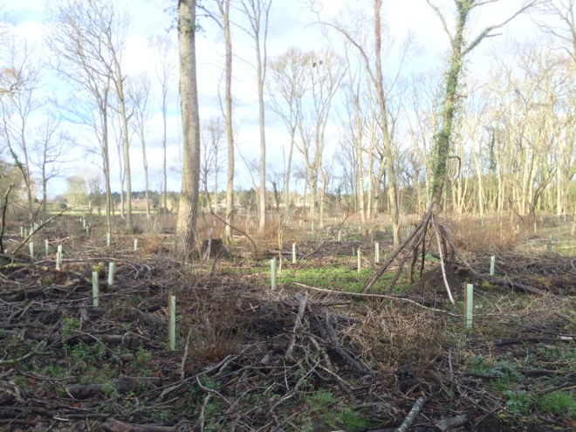
8.1.6 Caldecote House Farm Woodlands
There are four separate woodlands located on the Caldecote House Farm namely Flitton Scar, Palmers Spinney, Lady Wood and New Plantation. Owned and managed by the Maudlin family they too benefit from a detailed management plan. They are a mix of ancient semi natural woodland, other semi natural woodland and plantation on ancient sites. All are highly visible within the wider landscape and are important feeding areas with breeding sites adjacent. Flitton Scar is the only one of the four that has access by a public right of way inside its southern boundary. Widening of this public access is recommended within the management plan to improve public amenity.
Caldecote House Farm Woodland Management
Again the management plan objectives appear to fit well with the NP environment objectives and improved access to Flitton Scar is noted. The NP could be used to explore with the landowner the possibilities of improving access to the other sites through permissive routes or the establishment of specific access periods designed to ensure that public access is achieved within the sensitive needs of the sites and sporting activity such as shooting.
8.1.7 Woodlands and The Green Infrastructure Plan (GIP)
As previously stated the GIP sets out some wide ranging aspirations and priorities and some are associated with woodland areas. These include:
- The creation of new footpaths through Home Wood linking Footpath 3 to Ickwell Park
- A new footpath link to improve access to Flitton Scar Wood from Caldecote Road
- The creation of new woodland at south of Footpath 12 by its junction with Footpath 40
- The enhancement of heritage, wildlife and access value of the fish pons in Home Wood.
Whilst none of these fall within the top five ranked priorities identified by workshop groups or individuals (as part of the GIP development process) the NP working group consider them to be important aspirations that will assist in achieving the NP objectives and as such they should be incorporated within the NP action plan.
Furthermore, the prioritisation of Flitton Scar Wood and the fishpond area within Home Wood as designated Local Green Space demonstrates the importance of these sites to the local community and the NP environment working group agrees that they should be designated as such through the Neighbourhood Plan.
8.2 Cropped land – arable and commercial production
8.2.1 Cropped land used for arable farming or market garden production provides our parish environment with wide open spaces, views and good flight paths for birds particularly to the north and east of our parish. Whilst they are farmed as an intensive monoculture they offer little by way of biodiverse habitat.
8.2.2 However, they could in future make an important contribution to the biodiversity network beyond that established within the GIP thus far. The CSS promoted by the Caldecote House Farm management team provides a good example of what can be achieved through commercial crop production. Commercial and contract producers prefer regular shaped land to farm in a highly mechanised manner. Fields are often irregular in shape and the creation of regular parcels of land within these spaces makes the residue of land suitable for creating field margins, wildlife cover and wildflower areas. This coupled with the replanting of hedgerows along fields boundaries provides an ideal opportunity to link the more biodiverse areas together across the parish and create wildlife corridors.
8.3 Grazing land and permanent grassland
8.3.1 There are approximately 71 hectares of permanent grassland in the parish much of which is used for grazing or the production of hay. Again these open areas are an important visual part of our landscape and help to create and maintain views. They also provide a unique habitat of their own with their own unique flora and fauna.
8.3.2 Some of the land at Ickwell Bury falls within this typology as grazed parkland. It is identified within the GIP as a priority for LGS designation and the working group would support such a designation. However, it is not readily accessible to the public at present and it could be considered to be an under utilised resource for our parish community.
8.4 Field margins
8.4.1 This typology is probably best suited for discussion and analysis of the Countryside Stewardship Scheme (CSS) and its positive impact on our parish environment.
8.4.2 The CSS is a Defra initiative managed by Natural England targeting 110 areas across England aiming to deliver significant environmental benefits in priority areas. With advice and support from local advisors, the scheme develops individual comprehensive 10 year agreements with those managing complex environmental areas aiming to achieve significant benefits over the 10 year period.
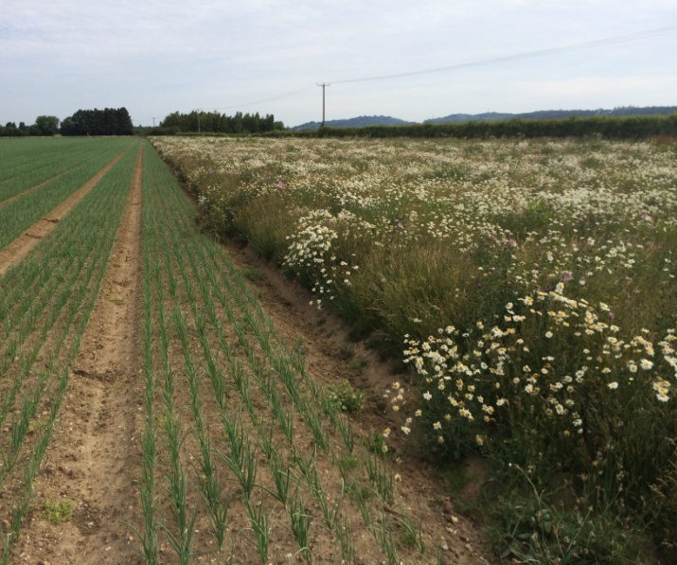
8.4.3 In our parish the scheme operates across large parts of Caldecote House Farm under the stewardship of the Caldecote House Farm management team. The team have responded to the decline in bird population and in particular grey partridge resulting from the intensification of agriculture from the 1970’s onwards. Through the CSS and EU grant funding the team is managing woodlands, hedgerows and field margins for the wider benefit of wildlife and in particular to create cover for the grey partridge. As a result the grey partridge has gone from 8 pairs in 2002 to 44 pairs in 2010. From the period 2006 to 2015 farmland bird density is also up by 1200%.
A typical Caldecote House Farm field margin
8.4.4 Species and predator control also forms part of the management scheme and the team are passionate about ensuing that what he is achieving is well understood by the local community. To this end they regularly gives talks to local groups and have also introduced some good on site interpretation material at various sites around the farm where the 3 village walks and the Greensand Ridge pathways cross the farmland.
8.4.5 The working group recognise the valuable contribution that the scheme makes to our environment and has identified that more needs to be done to promote such schemes within schools and the wider community so that local people can understand and support the benefits. To this end the group feels that the NP should include a policy statement on the publicity and promotion of such schemes to also include the valuable work that the Forestry Commission and the BRCC are doing at other sites discussed previously. This might take the form of more on-site interpretation, regular blogs on what to look out for each month or other web based media output.
8.4.6 As part of the review of the CSS the working group sought clarification on what other agricultural schemes other landowners are involved with. With the exception of the work by the new owner of College Wood to plant ancient Bedfordshire fruit trees and better manage the ancient woodland. There is to date no evidence of other formal schemes in operation. It is therefore suggested that the NP includes a policy statement to further investigate this opportunity and where necessary encourage landowners to increase biodiversity within their farming business.
8.5 Water bodies – courses, ditches, lakes, ponds and reservoirs
8.5.1 There are number of water bodies located within the parish the largest of which is the Warren Villas nature reserve to the east alongside the River Ivel. The Warren Villas complex of lakes was developed as a result of sand and gravel extraction and was managed for a period of 25 years as a nature reserve creating the thriving wildlife habitat that we see today. The reserve was sold a few years ago to a private owner and is currently run managed and used as a commercial fishery. Thee are some permissive rights of way in place.
8.5.2 It has not yet been possible to obtain any detailed information about the management of the site and the extent and importance of the habitats created when managed as a nature reserve. The working group would encourage the inclusion within the NP of an action to research this area more fully and work closely with the owner to determine improved permissive rights and establish detailed management plans. It should be noted that this complex of water-based habitats is a good contrast to the wooded areas to the west of the parish and the open land to the central belt.
8.5.3 The other potentially important water body in the parish is located within the Ickwell Bury parkland. The parkland boasts a serpentine lake set in a ‘Capability Brown’ style parkland setting. The BRCC ‘Secrets of the Sands’ project mentioned previously recognises the importance and historic value of the Ickwell Bury parkland and the need to conserve and promote such landscapes as a value community resource.
8.6 Open spaces - road verges, managed public open space, hedgerows and churchyards.
8.6.1 Open spaces and their margins along with roadside verges play an important part in creating a series of connected spaces in the parish. Despite the fact that our parish is rural in nature these types of open spaces are the only part of our green environment that many of our parishioners will experience on a daily basis. They are also important spaces for the movement of wildlife.
8.6.2 Our publically maintained village greens and playing fields are well protected from built development but there is little evidence of any real or meaningful development of these areas as community spaces where our residents can experience nature first hand. Whilst they contain a mix of hedgerows, ditches, grass banks, mature trees and close mown grass there has not been, until very recently, any plan to develop these as more biodiverse better connected green spaces with good local interpretation.
8.6.3 The Northill Parish Green Infrastructure Plan represents one of the best opportunities to develop these spaces. The proposed designation of Ickwell, Caldecote and Northill greens as Local Green Spaces is to be commended but this must be accompanied by policies and plans emerging from the NP to challenge and diversify management regimes, to create differential mowing margins, encourage flourishing wildflower populations and improve signage and on-site wildlife information.
8.6.4 A couple of the specific comments noted within the ‘Responses from Public Consultation document’ at Appendix 1 make specific reference to this typology. The working group would, in particular, comment on the following:
- ‘Landscape the approaches to the village where land is available’ – The group supports this suggestion but care must be taken to ensure that the landscaping is in keeping with the nature and character of our rural community. Highly ornamental landscaping should be avoided.
- ‘Maintain and conserve hedgerows’ at various locations - The group supports this suggestion but care should be taken to avoid these all becoming a public maintenance responsibility and owners should encouraged and incentivised to manage hedgerows sensitively and for the benefit of wildlife.
8.6.5 With regard to the importance of habitat preservation and the protection of flora and fauna the working group has been able to find little evidence that surveying and recording of important species has taken place in these open spaces. Whilst it is recognised that the Biological Records Centre hold some useful data for our parish and there is a Bedfordshire network of volunteer recorders it should be noted that the survey and research work achieved thus far relates primarily to the important designated spaces such as Home Wood or to specific species favoured by the recorders. The NP needs to include a policy which encourages a better understanding of our parish flora and fauna across all areas including open spaces. The data collected in the past by Mr Alan Wakeford and published on a monthly basis is a prime example of what can be achieved at a very local level by local people.
8.6.6 Our community’s local churchyards at All Saints church in Upper Caldecote and St Mary’s church in Northill are also recognised as places beneficial to wildlife. An A-Z of churchyard conservation can be obtained through the ‘Caring for God’s Acre’ initiative and further study may well link well with the outcomes of the working group looking at our historic environment
8.7 Allotment and community orchard
8.7.1 There has been much said, discussed and written about the need for publically managed and affordable parish allotments in the last few years and there overwhelming evidence from surveys and public consultation that they are a much needed and valuable resource to our community. Coupled with the desire to create a community orchard, both the allotments and the orchard can make an important contribution to the health and wellbeing of our community.
8.7.2 The mechanism for delivery, once a site is secured, is well established and the Northill Parish Allotment Association (NPAA) in partnership with the Parish Council are well prepared to move forward with such an initiative. Appendix 3 provides a copy of the NPAA report outlining the delivery mechanism.
8.7.3 The delivery of Objectives CF02 and CF03 remains problematic. A number of parcels of land have been identified as potentially suitable for the creation of allotments and a community orchard. However, these remain difficult to secure for such use whilst there remains the potential for landowners to develop the sites for housing.
8.7.4 It has therefore only been possible to identify potential sites with good access and ease of development at this stage and moving forward is dependent on the work of the housing site allocations group completing its assessment of suitable housing sites. The sites considered suitable are shown on the map at Appendix 4 and are listed below.
1. Bryant’s Land at the back of Tower Café
2. Council / Church land adjacent to Caldecote Lower School / village green.
3. Taddy’s Field
4. Land behind new affordable housing in Biggleswade Rd (south side)
5. Land opposite new affordable housing in Biggleswade Rd (north side)
6. Land at Ickwell Bury including the walled garden. (Subject to it not being rendered unavailable due to the potential for it being an important archaeological site)
8.7.5 Much has also been said about the need for suitable soil for growing and crop production and whilst it is clear that land in the flood plain or on extremely heavy clay or gravely soils should be avoided most land can be improved over time and indeed prepared as part of the development process.
9. Conclusion
9.1 Our parish environment is clearly diverse with both historic and more modern aspects and a wide range of environment types. By and large the working group considers that land is well managed by local landowners and other agencies. However, there are significant opportunities though the establishment of the Neighbourhood Plan to build on the success already achieved, to improve physical access for our wider community, to increase the knowledge and understanding of our complex environment and to use it as a means for healthy living both in mind and body.
10. Recommendations
10.1 Section 4 of this report details a number of opportunities that can be taken forward for inclusion in the Neighbourhood Plan and the Environment Working Group recommends that the NP Steering Group consider these points further with a view to adopting policies, strategies and action plans than can assist in their delivery.
11. Appendices
Appendix 1 - Responses from Public Consultation Workshops June – September 2015.
Appendix 2 (A, B, and C) – College Wood and Home Wood Management Plans and Caldecote House Farm Management Plan.
Appendix 3 - NPAA report outlining the delivery mechanism for a secured allotment site.
Appendix 4 – Map of potential land suitable for allotment provision.

